The Fourth Sunday in Lent
St. Peter’s Episcopal Church
30 Church Street, P.O. Box 513
Hebron, CT 06248-0513
The Rev. Ronald J. Kolanowski, Rector
Joshua Ziemski, Organist & Choir Director
860-228-3244
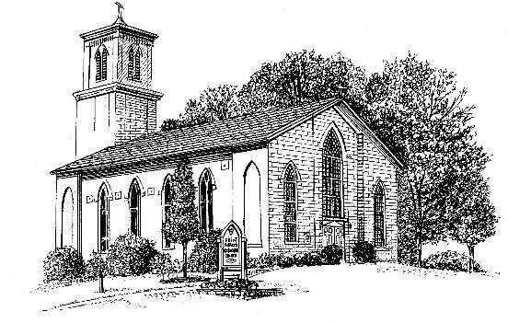

The FOURTH Sunday in Lent
March 14, 2021

Prelude

Opening Hymn: #620 “Jerusalem, my happy home”
A Penitential Order
Celebrant Bless the Lord who forgives all our sins.
People His mercy endures for ever.

The Decalogue:
Hear the commandments of God to his people:
I am the Lord your God who brought you out of bondage.
You shall have no other gods but me.
Amen. Lord have mercy.
You shall not make for yourself any idol.
Amen. Lord have mercy.
You shall not invoke with malice the Name of the Lord your God.
Amen. Lord have mercy.
Remember the Sabbath day and keep it holy.
Amen. Lord have mercy.
Honor your father and your mother.
Amen. Lord have mercy.
You shall not commit murder.
Amen. Lord have mercy.
You shall not commit adultery.
Amen. Lord have mercy.
You shall not steal.
Amen. Lord have mercy.
You shall not be a false witness.
Amen. Lord have mercy.
You shall not covet anything that belongs to your neighbor.
Amen. Lord have mercy.

Celebrant: Let us humbly confess our sins unto Almighty God.
Confession of Sin
Most merciful God, we confess that we have sinned against thee in thought, word, and deed, by what we have done, and by what we have left undone. We have not loved thee with our whole heart; we have not loved our neighbors as ourselves. We are truly sorry and we humbly repent. For the sake of thy Son Jesus Christ, have mercy on us and forgive us; that we may delight in thy will, and walk in thy ways, to the glory of thy Name. Amen.

Absolution
Almighty God, our heavenly Father, who of his great mercy hath promised forgiveness of sins to all those who with hearty repentance and true faith turn unto him, have mercy upon you, pardon and deliver you from all your sins, confirm and strengthen you in all goodness, and bring you to everlasting life; through Jesus Christ our Lord. Amen.

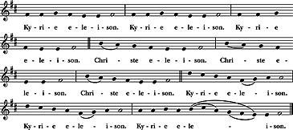
S- 86 Kyrie eleison

Collect of the Day
Gracious Father, whose blessed Son Jesus Christ came down from heaven to be the true bread which gives life to the world: Evermore give us this bread, that he may live in us, and we in him; who lives and reigns with you and the Holy Spirit, one God, now and for ever. Amen.

The First Reading: Numbers 21:4-9
From Mount Hor the Israelites set out by the way to the Red Sea, to go around the land of Edom; but the people became impatient on the way. The people spoke against God and against Moses, “Why have you brought us up out of Egypt to die in the wilderness? For there is no food and no water, and we detest this miserable food.” Then the Lord sent poisonous serpents among the people, and they bit the people, so that many Israelites died. The people came to Moses and said, “We have sinned by speaking against the Lord and against you; pray to the Lord to take away the serpents from us.” So Moses prayed for the people. And the Lord said to Moses, “Make a poisonous serpent, and set it on a pole; and everyone who is bitten shall look at it and live.” So Moses made a serpent of bronze, and put it upon a pole; and whenever a serpent bit someone, that person would look at the serpent of bronze and live.
Reader: The Word of the Lord. People: Thanks be to God.

The Psalm: Psalm 107:1-3, 17-22
1 Give thanks to the Lord, for he is good, *
and his mercy endures for ever.
2 Let all those whom the Lord has redeemed proclaim *
that he redeemed them from the hand of the foe.
3 He gathered them out of the lands; *
from the east and from the west,
from the north and from the south.
17 Some were fools and took to rebellious ways; *
they were afflicted because of their sins.
18 They abhorred all manner of food *
and drew near to death's door.
19 Then they cried to the Lord in their trouble, *
and he delivered them from their distress.
20 He sent forth his word and healed them *
and saved them from the grave.
21 Let them give thanks to the Lord for his mercy *
and the wonders he does for his children.
22 Let them offer a sacrifice of thanksgiving *
and tell of his acts with shouts of joy.

The Second Reading: 1 Ephesians 2:1-10
You were dead through the trespasses and sins in which you once lived, following the course of this world, following the ruler of the power of the air, the spirit that is now at work among those who are disobedient. All of us once lived among them in the passions of our flesh, following the desires of flesh and senses, and we were by nature children of wrath, like everyone else. But God, who is rich in mercy, out of the great love with which he loved us even when we were dead through our trespasses, made us alive together with Christ-- by grace you have been saved-- and raised us up with him and seated us with him in the heavenly places in Christ Jesus, so that in the ages to come he might show the immeasurable riches of his grace in kindness toward us in Christ Jesus. For by grace you have been saved through faith, and this is not your own doing; it is the gift of God-- not the result of works, so that no one may boast. For we are what he has made us, created in Christ Jesus for good works, which God prepared beforehand to be our way of life.

Reader: The Word of the Lord. People: Thanks be to God.

Sequence Anthem

Celebrant: The Holy Gospel of our Lord Jesus Christ

People: Glory be to thee, O Lord

The Holy Gospel: John 3:14-21
Jesus said, “Just as Moses lifted up the serpent in the wilderness, so must the Son of Man be lifted up, that whoever believes in him may have eternal life.

“For God so loved the world that he gave his only Son, so that everyone who believes in him may not perish but may have eternal life.
“Indeed, God did not send the Son into the world to condemn the world, but in order that the world might be saved through him. Those who believe in him are not condemned; but those who do not believe are condemned already, because they have not believed in the name of the only Son of God. And this is the judgment, that the light has come into the world, and people loved darkness rather than light because their deeds were evil. For all who do evil hate the light and do not come to the light, so that their deeds may not be exposed. But those who do what is true come to the light, so that it may be clearly seen that their deeds have been done in God.”

Celebrant: The Gospel of the Lord People: Praise to thee, O Christ

Sermon The Rev. Ron Kolanowski

The Nicene Creed
We believe in one God, the Father, the Almighty,
maker of heaven and earth, of all that is, seen and unseen.
We believe in one Lord, Jesus Christ, the only Son of God, eternally begotten of the Father, God from God, Light from Light, true God from true God, begotten, not made, of one Being with the Father.
Through him all things were made. For us and for our salvation
he came down from heaven: by the power of the Holy Spirit
he became incarnate from the Virgin Mary, and was made man.
For our sake he was crucified under Pontius Pilate;
he suffered death and was buried.
On the third day he rose again in accordance with the Scriptures;
he ascended into heaven
and is seated at the right hand of the Father.
He will come again in glory to judge the living and the dead,
and his kingdom will have no end.
We believe in the Holy Spirit, the Lord, the giver of life,
who proceeds from the Father and the Son.
With the Father and the Son he is worshiped and glorified.
He has spoken through the Prophets.
We believe in one holy catholic and apostolic Church.
We acknowledge one baptism for the forgiveness of sins.
We look for the resurrection of the dead,
and the life of the world to come. Amen.

The Prayers of the People for Lent
Leader: Brothers and sisters in Christ: Let us pray that the peace accomplished through the Cross of Christ may be realized in our own world and our own relationships. Let us pray for the Church and the world God so loves, for peace among all nations, and for the reconciliation of all people and all things in the Name of Christ.
Silence
God of love, in your mercy,

People: Hear our prayer.
Leader: Almighty God, your Son our Savior Jesus Christ was lifted high upon the cross that he might draw the whole world to himself: Mercifully grant that we, who glory in the mystery of our redemption, may have the grace to take up our cross and follow him in pursuit of your work of reconciliation in the world.
Silence
God of love, in your mercy,
People: Hear our prayer.
Leader: For the holy catholic church throughout the world, a sign on earth of the kingdom of God. In the Diocesan Cycle of Prayer, we pray for Grace & St. Peter’s, Hamden; Christ Church Cathedral, Hartford; Good Shepherd, Hartford; Bishops, ECCT staff, and parish employees, and their families.
Silence
God of love, in your mercy,
People: Hear our prayer.
Leader: For Michael our presiding bishop, for Ian, and Laura, our bishops, for our priest Fr. Ron and for Donna, our deacon and all who minister in Christ, and for all the holy people of God.
Silence
God of love, in your mercy,
People: Hear our prayer.
Leader: For our families, friends, and companions, and for all those we love. We pray for those celebrating their birthdays this week: Megan Sulzinski [3/16], Bob Winter [3/18], Stephen Fisk [3/19], Walter Marino [3/20], Peter Bradley [3/23], Robin Messenger [3/23];
Silence
God of love, in your mercy,
People: Hear our prayer.
Leader: For all who are tempted, oppressed, afflicted, or in need or sickness, especially those in our bulletin who have asked for our prayers, especially Ella & Nicole; Everett Stickland;
Silence
God of love, in your mercy,
People: Hear our prayer.
Leader: For the dying and the dead. The Sanctuary Candle is given to the glory of God in loving memory of Guy Colaccino (Robin Kenefick's dad)
Silence
God of love, in your mercy,
People: Hear our prayer.

Celebrant: For what else shall we pray this day?

Let us pray:

O Lord our God, accept the fervent prayers of your people; in the multitude of your mercies look with compassion upon us and all who turn to you for help: for you are gracious, O lover of souls, and to you we give glory, Father, Son, and Holy Spirit, now and forever. Amen.

The Peace

The Offertory

Offertory Hymn: #302 “Father, we thank thee who hast planted”

The Great Thanksgiving BCP, page 333
Eucharistic Prayer I
Celebrant: The Lord be with you
People: And with thy spirit
Celebrant: Lift up your hearts.
People: We lift them up unto the Lord
Celebrant: Let us give thanks unto our Lord God.
People: It is meet and right so to do.

Then the Celebrant proceeds
It is very meet, right, and our bounden duty, that we should at all times, and in all places, give thanks unto thee, O Lord, holy Father, almighty, everlasting God.

Therefore, with Angels and Archangels, and with all the company of heaven, we laud and magnify thy glorious Name; evermore praising thee, and saying,

Sanctus: S-124“Holy, holy, holy Lord” Powell
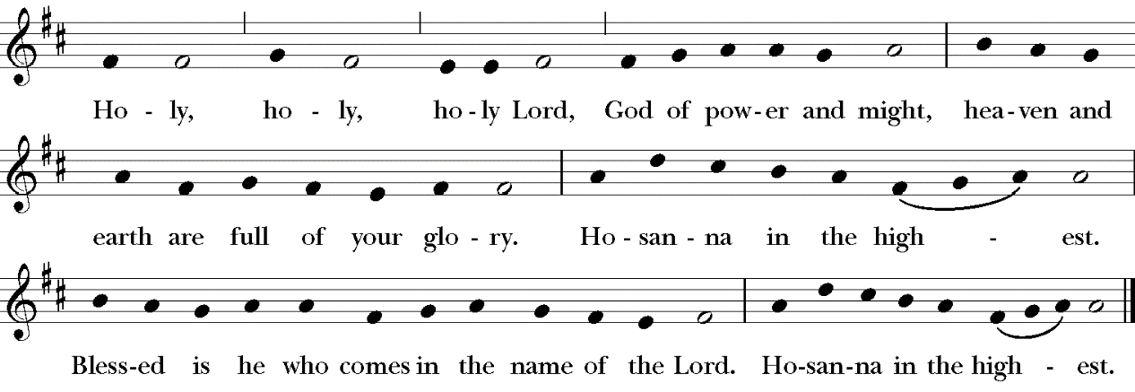

All glory be to thee, Almighty God, our heavenly Father, for that thou, of thy tender mercy, didst give thine only Son Jesus Christ to suffer death upon the cross for our redemption; who made there, by his one oblation of himself once offered, a full, perfect, and sufficient sacrifice, oblation, and satisfaction, for the sins of the whole world; and did institute, and in his holy Gospel command us to continue, a perpetual memory of that his precious death and sacrifice, until his coming again.

For in the night in which he was betrayed, he took bread; and when he had given thanks, he brake it, and gave it to his disciples, saying, "Take, eat, this is my Body, which is given for you. Do this in remembrance of me."

Likewise, after supper, he took the cup; and when he had given thanks, he gave it to them, saying, "Drink ye all of this; for this is my Blood of the New Testament, which is shed for you, and for many, for the remission of sins. Do this, as oft as ye shall drink it, in remembrance of me."

Wherefore, O Lord and heavenly Father, according to the institution of thy dearly beloved Son our Savior Jesus Christ, we, thy humble servants, do celebrate and make here before thy divine Majesty, with these thy holy gifts, which we now offer unto thee, the memorial thy Son hath commanded us to make; having in remembrance his blessed passion and precious death, his mighty resurrection and glorious ascension; rendering unto thee most hearty thanks for the innumerable benefits procured unto us by the same.

And we most humbly beseech thee, O merciful Father, to hear us; and, of thy almighty goodness, vouchsafe to bless and sanctify, with thy Word and Holy Spirit, these thy gifts and creatures of bread and wine; that we, receiving them according to thy Son our Savior Jesus Christ's holy institution, in remembrance of his death and passion, may be partakers of his most blessed Body and Blood.
And we earnestly desire thy fatherly goodness mercifully to accept this our sacrifice of praise and thanksgiving; most humbly beseeching thee to grant that, by the merits and death of thy Son Jesus Christ, and through faith in his blood, we, and all thy whole Church, may obtain remission of our sins, and all other benefits of his passion.

And here we offer and present unto thee, O Lord, ourselves, our souls and bodies, to be a reasonable, holy, and living sacrifice unto thee; humbly beseeching thee that we, and all others who shall be partakers of this Holy Communion, may worthily receive the most precious Body and Blood of thy Son Jesus Christ, be filled with thy grace and heavenly benediction, and made one body with him, that he may dwell in us, and we in him.

And although we are unworthy, through our manifold sins, to offer unto thee any sacrifice, yet we beseech thee to accept this our bounden duty and service, not weighing our merits, but pardoning our offenses, through Jesus Christ our Lord;

By whom, and with whom, in the unity of the Holy Ghost, all honor and glory be unto thee, O Father Almighty, world without end. AMEN.

And now, as our Savior Christ hath taught us, we are bold to say,

Our Father who art in heaven, hallowed be thy Name,

thy kingdom come, thy will be done,
on earth as it is in heaven.
Give us this day our daily bread. And forgive us our trespasses,
as we forgive those who trespass against us.
And lead us not into temptation, but deliver us from evil.
For thine is the kingdom, and the power,
and the glory, for ever and ever. Amen.

The Breaking of the Bread
Celebrant: Christ our Passover is sacrificed for us.

People: Therefore, let us keep the feast.

Fraction Anthem “Jesus Remember Me”
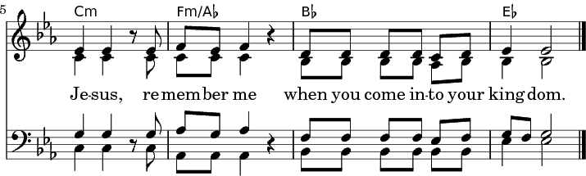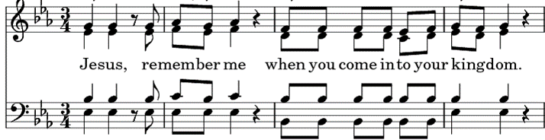

Celebrant:
The Gifts of God for the People of God.
Take them in remembrance that Christ died for you,
and feed on him in your hearts, by faith, with thanksgiving.

Spiritual Communion Prayer
God of love and grace, of justice and peace, we give you thanks that in the Sacrament of the altar you assure us of your presence within us and within the body of Christ, the faithful through all the generations; grant that we who have witnessed anew these holy mysteries, though unable to receive the physical elements of the Sacrament, may be moved by your indwelling Spirit ever more fully to embody your holy and life-giving presence, reshaping in your likeness the world around us, until we are gathered at last into the fullness of your glorious and eternal presence; through Christ our Risen Lord, Amen

Communion Music

Post-Communion Prayer BCP, page 339
Celebrant: Let us pray.

All: Almighty and everliving God, we most heartily thank thee for that thou dost feed us, in these holy mysteries, with the spiritual food of the most precious Body and Blood of thy Son our Savior Jesus Christ; and dost assure us thereby of thy favor and goodness towards us; and that we are very members incorporate in the mystical body of thy Son, the
blessed company of all faithful people; and are also heirs, through hope, of thy everlasting kingdom. And we humbly beseech thee, O heavenly Father, so to assist us with thy grace, that we may continue in that holy fellowship, and do all such good works as thou hast prepared for us to walk in; through Jesus Christ our Lord, to whom with thee and the Holy Ghost, be all honor and glory, world without end. Amen.

The Blessing

Closing Hymn: #690 “Guide me, O thou great Jehovah”

Dismissal

People: Thanks be to God.
Postlude

Continuing Prayer List: Connie Keefe, Donna Gray, Sandy Marshall, George Dagon, Scott, Karen Thom, Phyllis Swanson, Lynne A., Celeste Moore; Rowan; Joan Hamilton; Stephen, Ambrosio Vidal and family, Eileen Doughty, Phil “Chip” Lewis, Stephen, Kate, Tammy Lopez; Teddi; Sean, Caroline; Russ Boehle, Emma; Janice, Jared and Jenna; Daniel Paez, Kyle Ethan; Sharon, Tim Redden; "Cousin" Phil & Norm H.; Cole; Alyssa & Kayden, Mary; Loretta Ickes, Cheryl & Bruce, Val & Stephen, Tina, John & Dottie, Gloria, Maryellyn, J & J, Arlene, Judy P., Bill, Liz, Nancy, Katy, Chris; Sarah McCracken, Ginny Hellstrom, Jacob Mika; Alice & Bob; John; Cailin & son Connor Campbell; Richard; Flora; Alice Wentz; Daryl Cook; Megan Sulzinski, Janet Kay; Ella; Liz; Bill S.; Patty Sullivan; Marcia Brown; John & family; Jeanette Wade; Susan Hicks & family; Jeannette Farren & family; Grace Jensen; Becky, June; Ella & Nelson; James; Rina Bettancourt; Alberta’s granddaughter, Jessica.

ANNOUNCEMENTS

Make your Easter Reservations Now
We encourage you to register soon so we know what to anticipate for Easter Sunday, April 4 with three services 7:30a.m.; 9:00a.m.; and 11:00a.m. We will have 24 pews available for reservation. Each pews can hold a maximum of four people or three large people comfortably. If you have more than four people coming please have someone make a separate reservation, since counting pews will be important. Once the church is full we will start reservations for the parish hall. To register simply go to the link Welcome to St. Peter's Episcopal Church in Hebron Connecticut If you are a single person and willing to share a pew with one other person simply write it in the comments in your reservation.

Healing Hearts Continues
In our HAT meeting today AHM Youth and Family Services announced that in addition to counseling for youth who are experiencing mental health issues that AHM is provided onsite services to teachers and staff at RHAM who have impacted by the stresses of these times. We encourage you to go to http://www.AHMYouth.org and donate to their Healing Hearts program to help with mental health illness among our youth in the greater Hebron area.

UP & COMING EVENTS
Every Wednesday: All are welcome to join our zoom Wednesday Coffee hours at 10 a.m. To join:
https://us02web.zoom.us/j/86121371917?pwd=SW02TW1ldUJJZHY2cUl5ZXYzdS9zZz09

Prayer and Pastoral Care Monday, March 15 1:00 p.m. Phelps Hall
Vestry Meeting via zoom, March 18, 7:00p.m.
Community Events/Fundraising Meeting March 31 7:00 p.m. via zoom.
Polish Dinner (March 20, 4:30-6:30)

